TARBERT & SKIPNESS COMMUNITY TRUST

Spring 2021 Newsletter

COVID-19

Before Christmas and during the second lockdown Tarbert & Skipness Community Trust have continued to support Team Tarbert. Christmas food gifts and Easter parcels were distributed to older people throughout Tarbert and Skipness. Several have written back thanking Team Tarbert and the Trust as sometimes a friendly face at the door is enough to lift spirits.

As the lockdown started in January the Trust contacted Tarbert Academy asking what help could be offered to children and families home schooling. We were able to help the school with a further 10 Chromebooks for both the primary and secondary schools.

Wall mounted hand sanitisers have been distributed to 7 halls and sports groups to support their start up following lockdown.

WHITE SHORE PATH AND CYCLE STANDS

In March 2021 the Trust organised a meeting with officials from Argyll and Bute Council and, as a result, the Trust received grants to repair the White Shore Path and purchase bike stands, table and bench to be installed on the walkway near Earra Gael. We had to move fast because the projects had to be costed, materials ordered or bought, and the work underway by the end of April.

The cycle racks and furniture are on order and cyclists doing the 5 Ferries route can now safely park their bikes and even stay with them while they have their lunch.

You may have noticed that work on the White Shore Path is underway. The bridges and boardwalks will be replaced and the path gravelled where it is boggy. New steps and drainage will be made down to the beach.
This work follows the tremendous work done by a local family during lockdown. These volunteers retrieved sand bags from the burn to rebuild the path at the bench viewpoint and directed the burn away from this area. The Trust is very grateful for their work.
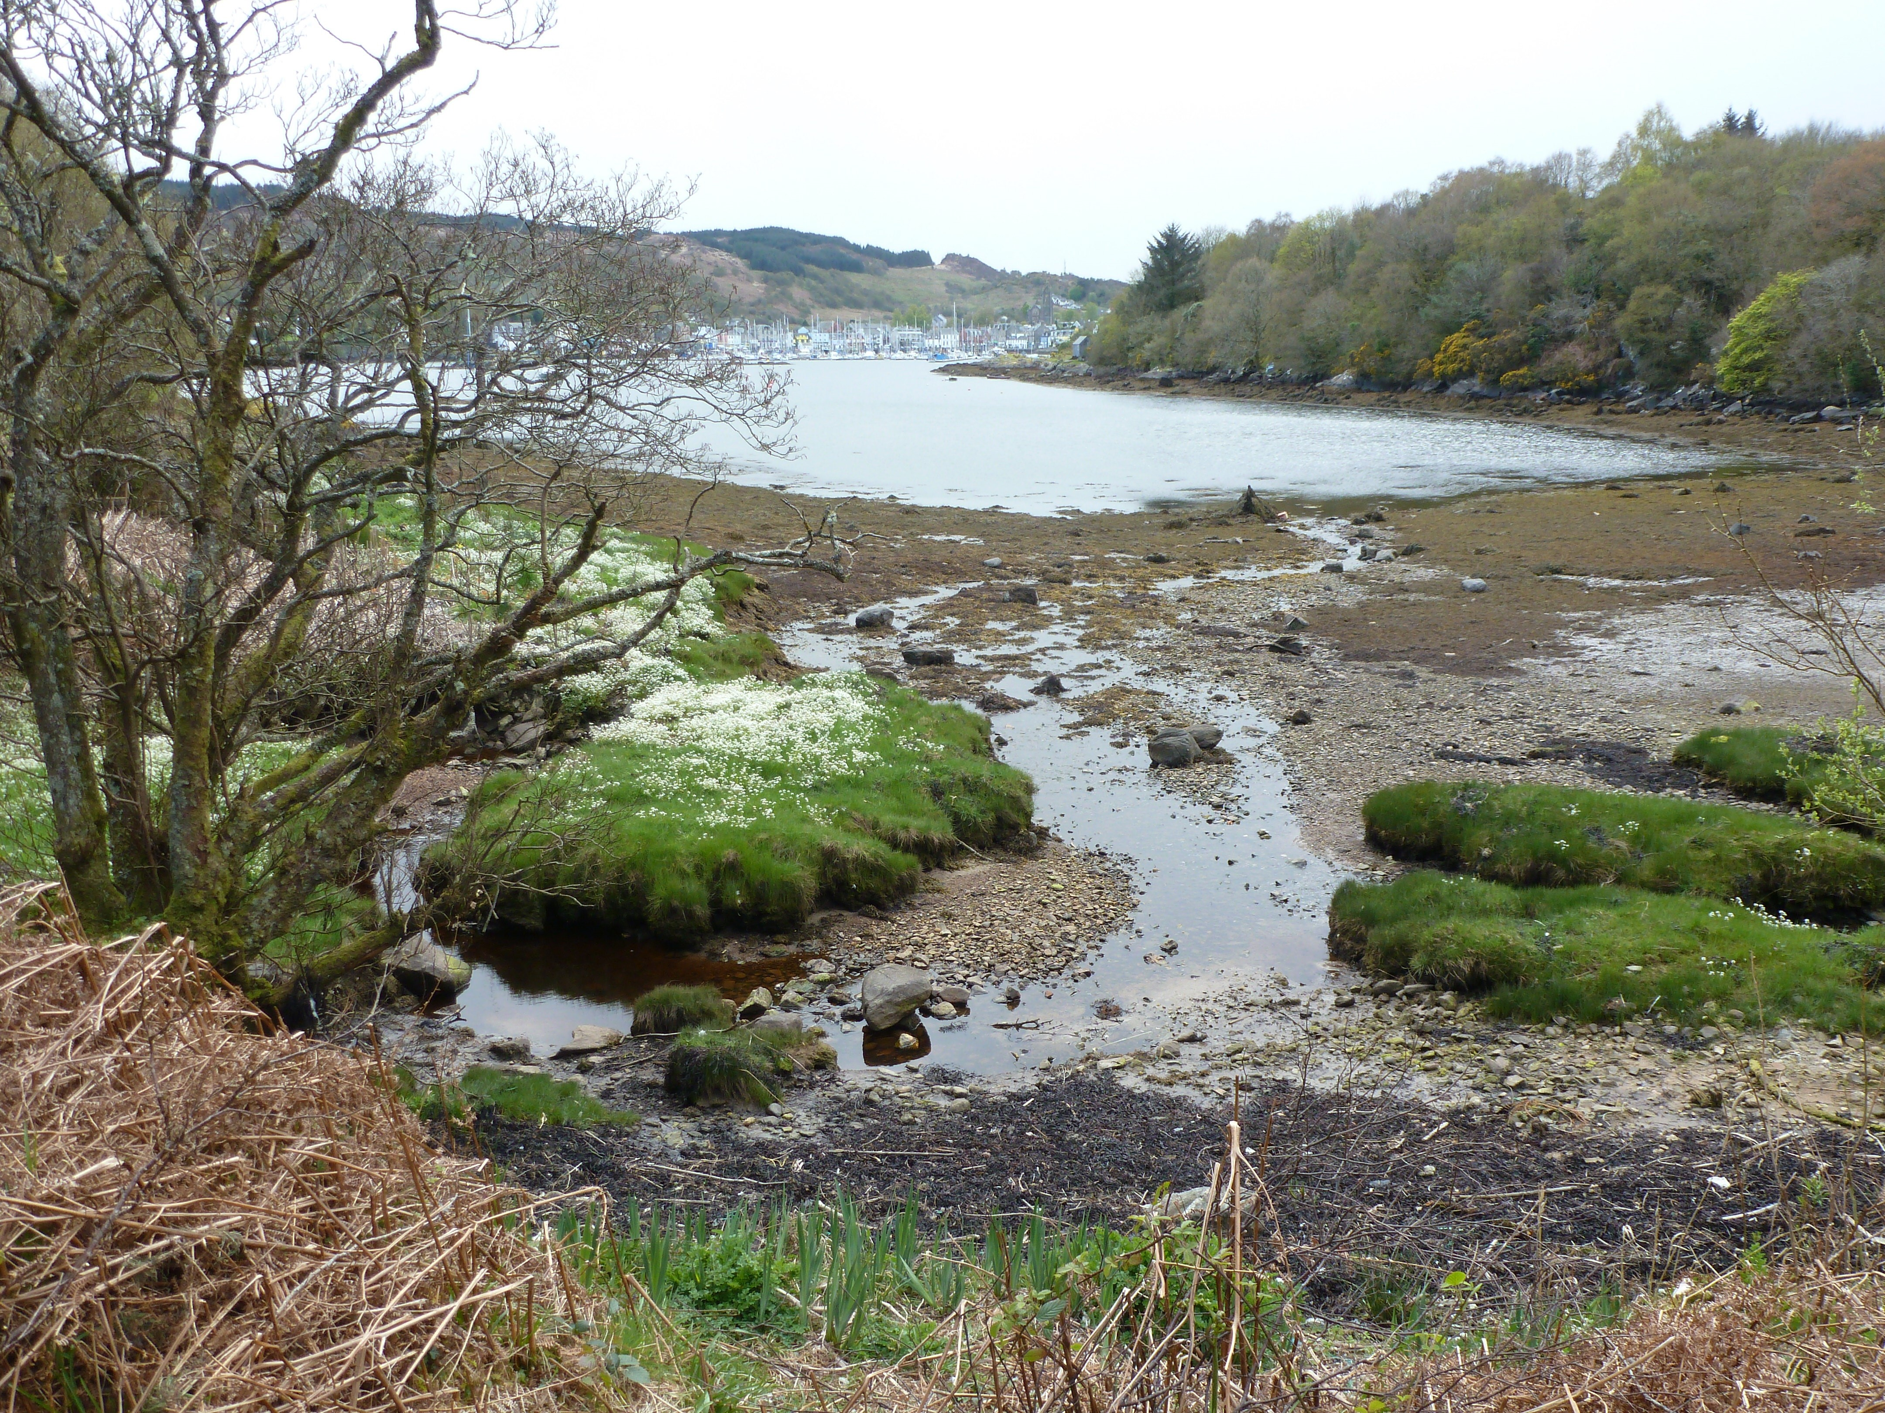

TARBERT LIFE

In our last newsletter we reported that we had moved out of the former Visitor Information Centre. The Trust hopes that Visit Scotland will soon find a new buyer or tenant for the building to bring energy and opportunity to this special space in the middle of the village.

Tarbert Life has not been idle. Many of the exhibition boards have now been put on its their website https://tarbertlife.co.uk and contributors are coming forward with new ideas for displays.
2021 in the centenary of the Tarbert war memorial and there is an offer of a new display commemorating the people and stories of those remembered there.

All other boards will be added in due course

To all our volunteers who worked so hard on the display, do not despair. The Trust is actively looking for premises where we can re-locate the display and develop Tarbert’s own heritage story. As soon as we have further news the display volunteers will be contacted to help with developing the project.
COMMUNITY BENEFIT DISPERSAL

RES Freasdail Community Benefit opens for applications on May 1st until 31st May 2021. Application forms and guidance can be found on the Trust website www.tsct.org.uk

ANNUAL BEACH CLEAN

Unfortunately, the annual beach clean in 2020 was victim of Covid-19. Following the repair of the White Shore path the Trust will organise a beach clean.

Thanks to local volunteers, the White Shore is looking good but there is a lot of work to be done around the shore to the bird hide and the far end of the White Shore.

IF YOU ARE GOING FOR A WALK ALONG THE SHORE, PLEASE TAKE A BAG AND A PAIR OF GLOVES AND COLLECT LITTER. THIS IS A SIMPLE WAY OF HELPING UNTIL WE CAN GET A FULL BEACH CLEAN. TARBERT HARBOUR AUTHORITY HAVE AGREED THAT LITTER COLLECTED CAN BE PLACED IN THEIR BINS

TSCT Board of Directors
Chair: Sheila Campbell | Company Secretary: Jane Cowen
Treasurer: John Rushton | Financial Director: Alistair Wilkie
Directors
Lorna Rushton, Tim James, James Hamilton, Wilma MacKenzie
Alex Horn

